Kidney, Bladder, and Urinary Tract Healthcare Solutions by Virus Treatment Centers [VirusTC]
Introduction
Urinary tract infections that lead to bladder cancer usually form after ingestion or injection of liquid hazardous chemicals. Chemotherapy is a leading cause of bladder cancers. Chemotherapy fluids such as Cyclophosphamide contain phage virus species used to attack large-breed tumors. Workplace chemical accidents involving arsenic, aromatic amines benzidine, and betanaphthylamine can cause bladder cancers. Some diabetes medications such as pioglitazone can cause bladder cancers.
Tars from GMO tobacco make their way to the liver. GMO tobacco products contain Typhus which is sprayed as a pesticide “Roundup”. Typhus species can attach themselves to the tissues of the bladder, grow, metastasize, uncoat the bladder, and rupture internal organs resulting in internal bleeding or death.
VirusTC developed our line of kidney, bladder, and urinary tract pathology oncology medications after receiving multiple complaints from doctors with patients passing pycnogonids through their genitalia. VirusTC medications protect internal organs by creating a plant-based protective biofilm within the urinary tract. Plant-based biofilms developed by VirusTC reduce metastasis, virus absorbtion, sores, uncoating, scarring, and pain associated with passing viral loads through the urinary tract.
Treatment success increases in cases where biofilm medications Siiaat KB+ and KB Basic are taken prior to other VirusTC pathology oncology medications. Biofilm medications should be taken 48hrs before treatments that intend to pass viral loads through the urinary tract.

Siiaat KB+ 1355mg
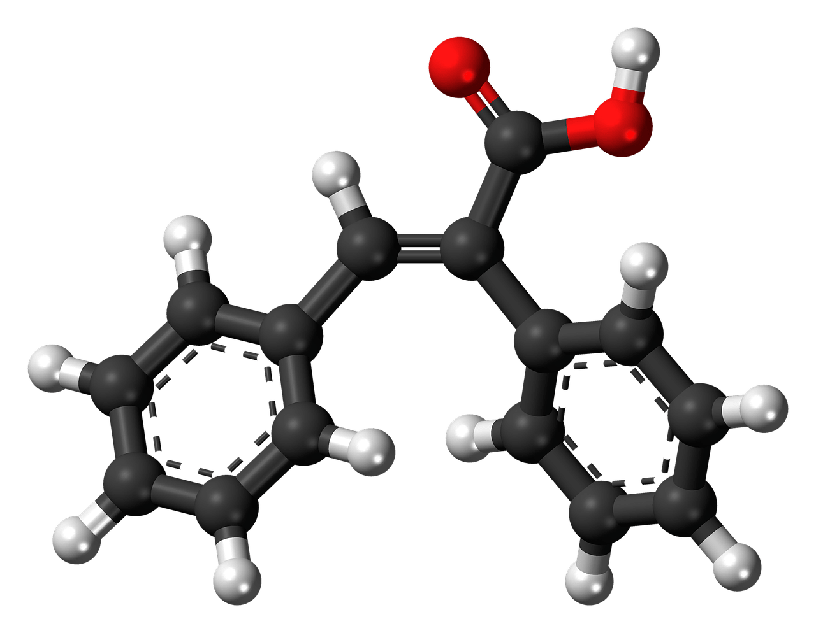
Siiaat KB+ is an FDA-Approved clinical medication used to clear large and small breed pycnogonids in the kidneys, bladder, and urinary tract. Siiaat KB+ often called “Siiaat Kiratbiri Plus” is rich in highly concentrated vaccinium macrcarpon. Vaccinium macrcarpon is a powerful attachment inhibitor that prevents pycnogonids from moving within the kidneys, bladder, and urinary tract without slipping and becoming unlodged. Siiat KB+ contains powerful antioxidants that melt-down, cook-off, and flush pycnogonids within the urinary tract. Siiaat KB+ is formulated for use with VirusTC medications without dosage modifications.

KB Basic 500mg
KB Basic is an FDA-Approved clinical medication used to flush the kidneys, bladder, and urinary tract. KB Basic “Kiratbiri Basic” is rich in highly concentrated vaccinium macrcarpon. Vaccinium macrcarpon is a powerful attachment inhibitor that prevents pycnogonids from moving within the kidneys, bladder, and urinary tract without slipping and becoming unlodged. KB Basic contains antioxidants that increase pH levels within the urinary tract. Siiaat KB+ is formulated for use with VirusTC medications without dosage modifications.

Melk D+
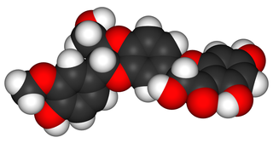
Melk D+ is an FDA-Approved clinical medication used to restore the urinary tract during cancer treatment. Melk D+ is rich in highly concentrated silymarin. Silymarin is a powerful antioxidant and anti-inflammatory medication used in regenerative medicine. Melk D+ reduces viral loads in the prostate. Melk D+ is formulated for use with VirusTC medications with dosage modifications. Each Melk D+ tablet contains 700mg of HaldEX. Melk D+ 1000mg 6 tablets daily, 2 tablets per meal REPLACES ANY VirusTC HaldEX PRESCRIPTION. Consuming large amounts of turmeric within 24 hours of taking Melk D+ can cause upset stomach or headaches.

